Introduction
Regional managers expressed concerns that the forecast of a large fall Chinook run could create overcrowding in The Dalles Dam’s east ladder, which is used by the majority of the fall fish passing the dam. Overcrowding has the potential to cause delays in passage. These delays may lead to longer periods of overcrowding in the ladder as more recruits show up. To address this concern, spill was proposed to increase the percentage of fish passing the north ladder and it was to be initiated for passage numbers >25,000 during the fall Chinook run. Increasing passage at the north ladder could theoretically alleviate the high numbers of fish passing at the east ladder. Spill began on Sept 9 and continued through Sept 15. At what point does overcrowding in the ladder due to high densities of fish have a negative effect on fish passage behavior? A sampling scheme was devised to monitor and attempt to identify changes in fish behavior during high densities of fish in the east ladder.
Method
To address this question a schedule of observations was set up to count the number s of fish passing via overflow at weir 153 in front of the east ladder count station (Figure 1). Project fisheries staff performed a one-hour count three times a week in a randomized scheme. During which time surface observations were made of visible fish and their behaviors. Sampling changed to everyday when the number of Chinook passing hit 20,000 at the east ladder. Sampling decreased to three times a week when spill stopped. Observation time was decided by randomly drawing from a pool of daylight hours 0700 to 1600 hours each sample day. The sampler watched the overflow areas of the weir and counted the number of fish that passed over during that hour with the assistance of a tally counter. Surface observations were also made of visible fish in pool and their behavior in order to detect any obvious crowding. Twenty samples were collected before observations were ended.
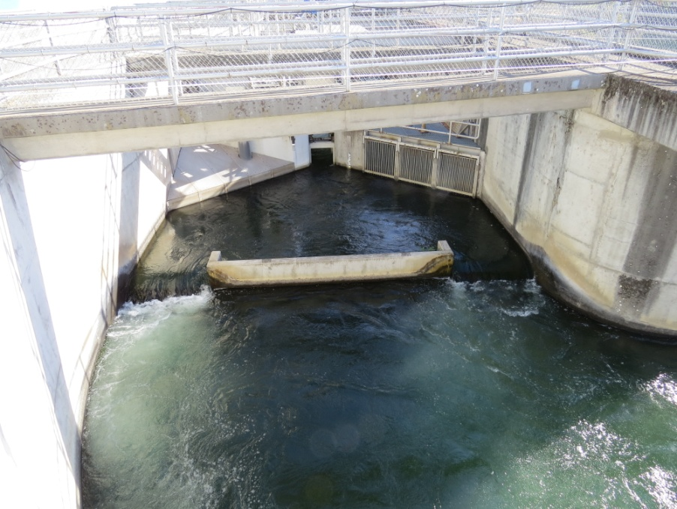
Figure 1. Observation area showing weir 153 just before the count station at The Dalles Dam east fish ladder 2014.
Result and Discussion
Data collected of fish passing over weir was compared to the fish counted passing through the count station window slot located in the pool above for the same hour of observation. In order to do this several assumption were made. First that the fish passing the overflow was similar for hours before and after the sample hour, second that fish steadily moved through the count station window and therefore could be easily compared to the fish passing the overflow without regards to passage delays. In Figure 2 the count over weir increases as the number of fish passing the station increases. However in Figure 3 the proportion of fish passing the count station that used the overflow does not increase linearly. Overflow usage did not appear to be effected by fish density. It is unknown if there were delays in passage due to high densities of fish trying to pass through the count window slot or if there was a higher level of fallback through the orifices at the count station areas.

Figure 2. The number of fish counted using the overflow at weir 153 versus the number of fish passing through the count station window within the same hour at The Dalles Dam east ladder 2014.

Figure 3 The proportion of fish passing the count station window at the east ladder of The Dalles Dam that were counted using the overflow within the same hour.
The effects of spill on fish passage at the east versus the north ladder are shown in the series of charts below. Spill began on September 9 from 0400 to 1600 and continued daily on this schedule ending September 15 at 1600. The north ladder passage increased as spill commenced and decreased when spill ended.

Figure 4. Salmon passage at the north and east fish ladders from Sept 7 through Sept 16, 2014. Spill was initiated September 9 through September 15 from 0400 to 1600 hours daily.

